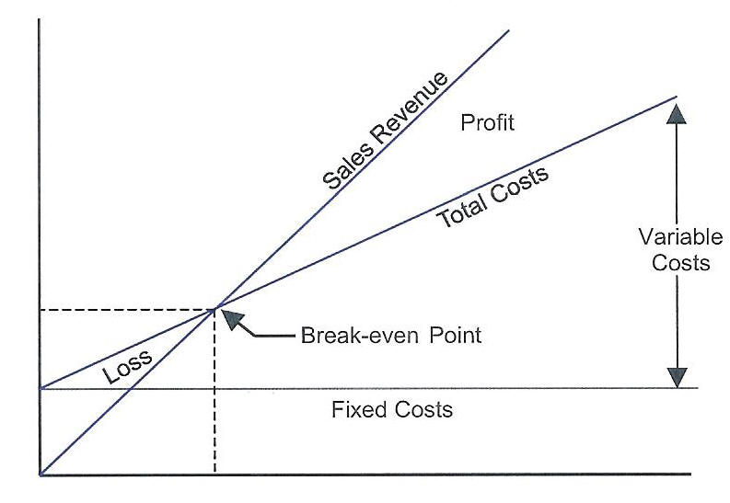
CSC 141: HWK #8: One Variable Data Table & Goal Seek

Instructions: Download the Light workbook and rename it as: lastname_hwk7 (replacing your last name). Complete the tasks below and upload your completed file via Blackboard.

Scenario: You have been asked to analyze cost-volume-profit relationship for product sales of Light Styk.
Tasks:
1. Complete the Documentation worksheet. Input the date as a function that will display the current date when opened.
2. Create a one-variable data table (beginning in the E column) in the Income Statement worksheet that calculates Revenue, Expenses and Net Income (hint: create three separate columns) for sales volumes ranging from 0 units sold to 30,000 units sold in increments of 5,000 units. Format the resulting values appropriately and build custom formats as appropriate.
3. Copy the Income Statement worksheet into a new worksheet and name it “Goal Seek”. Using Goal Seek, determine the number of Units that would need to be sold in order to generate Revenue of $170,000. Format the cell that displays the calculated number of Units with yellow fill.
4. Rename your worksheet: lastname_hwk8 (replacing your own last name) and upload it via the assignment link in Blackboard.

